*A Project report*

*on*

**INFORMATIVE WEBSITE**

**(READIT)**

*Submitted By*

BADIGINCHALA CHANDANA PRIYA - 20BCS026

BARLA SANJU JOHN - 20BCS028

ERIGI VAISHNAVI - 20BCS044

GUDISEVA DEEPAK SUJAY - 20BCS049

LALAM DIVYA SRI - 20BCS076

NAGELLA PRANAV REDDY - 20BCS089

*Under the guidance of*

Dr.Uma Sheshadri

Dr.Shankar Biradar



INDIAN INSTITUTE OF INFORMATION TECHNOLOGY

**ACKNOWLEDGMENT**

We are really grateful because we managed to complete our project "INFORMATIVE WEBSITE (READIT)" within the time given by our professors.The project could not be completed without the effort and contribution from our group members, Chandana, John, Vaishnavi, Deepak, Divya and Pranav.

We are also grateful to our professors Dr.Uma Sheshadri and Dr.Shankar Biradar for giving us this opportunity to let us explore our knowledge in new fields and understand the concepts, guiding and encouraging us for the completion of this project. The concepts we have learnt are brought into the practice, we have tried our best to make use of this opportunity. We would like to express our gratitude to our friends who helped and supported us for the completion of this project.

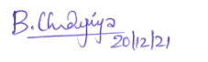 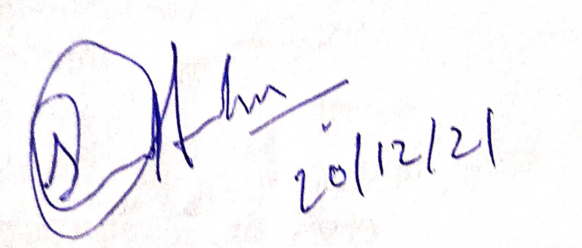

BADIGINCHALA CHANDANA PRIYA BARLA SANJU JOHN

( 20BCS026 ) ( 20BCS028 )

 

ERIGI VAISHNAVI GUDISEVA DEEPAK SUJAY

( 20BCS044 ) ( 20BCS049 )



LALAM DIVYA SRI NAGELLA PRANAV REDDY

( 20BCS076 ) ( 20BCS089 )

**ABSTRACT**

A discussion forum is a common tool in the online classroom. In addition to enhancing engagement, discussion forums can make thinking visible and help build community in your online course. It's important to implement forums carefully, as with any other course element. Using online forums can serve many purposes, including helping students review material prior to assignments or exams, engaging students in discussion of course material before class, and reflecting on material they have read or worked with outside of class. There are many types of forums like news forum, single simple discussion forum, question and answer forum. We used a question and answer forum, in which a user posts a question that is answered by other members of the community.

The concept behind this is to create a platform where students and users can participate actively in exploring new concepts. A huge amount of data has been collected on building these kinds of communities using discussion forums and we consulted various research papers for guidance. Students and users can find a lot of information on this forum, and communities of trust are created over time. Teachers and students can use the online discussion forum to maintain their communication outside of the classroom. Additionally, it provides students with an opportunity to participate in group discussions at any time and from any location; enabling them to provide and share their opinions with others. We personally consider the online discussion forum to be a great technology that helps students and teachers communicate as well as a great way for them to transfer knowledge. Lastly, we have created this to offer all of these benefits to students and members of our website as well as to build a community of trust.

**TABLE OF CONTENTS**

*Page. no.* Introduction - 6

1.1. About READIT *-6*

1.2. Aim and objective of the study -6

1.3. Scope of the study -7

1. Review of literature - 8
2. Methodology -10

3.1. Frontend  *-10*

3.1.1. HTML

3.1.2. CSS

3.1.3. JavaScript

3.2. Backend *-10*

3..2.1. Django

3.3. Database *-10*

3.3.1. Sqlite3

1. Designing Procedure -12

4.1. Work distribution  *-12*

4.2. UML diagram *-12*

4.3. Creating database and tables *-13*

4.4. 4.4.1. Login page -15

4.4.2. Navigation bar

4.4.3. Home page

4.4.4. Profile page

4.4.5. Contact us

4.4.6. About us

1. Results and discussions -18

5.1. Results *-18*

5.2. Discussion *-22*

1. Summary -23
2. References -24

**LIST OF FIGURES**

*Page. no.*

1. 4.1. UML diagram -12
2. 4.2. Code for preparation *User* table -14
3. 4.3. Code for preparation *Question* table -14
4. 4.4. Code for preparation *Answer* table -14
5. 4.5. Code for preparation *Category* table -14
6. 5.1. Sign in -18
7. 5.2. Sign up -19
8. 5.3. Home page -19
9. 5.4. Active categories -20
10. 5.5. My Profile -20
11. 5.6. About us -21
12. 5.7. Contact us -21

**CHAPTER 1**

**INTRODUCTION**

**1.1 Readit - An Informatory Website**

‘*Application*’, this word has been an essential part of today's lives. Hundreds of thousands of applications come into existence everyday across the internet and been used by millions of users across the world. This shows how applications become an important part of our life. This motivated us to make a web application named ‘***Readit***’.

*Readit* is an informatory web application which lets any registered user post their questions and any other registered users can answer their questions. Any person with access to the internet and email address can create their account, though only one user can be registered using one email address. For this application we used basic tools like *HTML, CSS,* and *JavaScript* along with that *Django* Framework was also used along with *Sqlite3* for database.



**1.2 Aim and Objectives of the Study**

Our main objective of this study is to implement a website by using and learning essential tools and techniques. For that we’ve divided ourselves into separate teams and learnt various tools for different resources.

Later on in our project many objectives were added and achieved successfully. We have to design an *UML* diagram for our project and lay it out, next to that we have to design web pages and create databases according to the proposed *UML* diagram.

**1.3 Scope of Study**

In this study there’s a lot of scope to study new concepts and apply practically at the same instance. We’ve learnt how web applications work, how a request and data is managed in websites etc. We’ve also studied *HTML, CSS, JavaScript, Bootstrap* and *Django* alongside ( different team members in different teams learnt various concepts ). Along with these we also learnt how database management systems works and how *AJAX* techniques can be used in these modern web applications.

**CHAPTER 2**

**REVIEW OF LITERATURE**

# **Literature Review based on various research paper**

**Dhanielly P. R. de Lima ET. AI.** [1] Our research found that online discussions enhance teaching and students' learning. However, studies indicate that some tutors and students are unsure about the value and quality of online discussions. Online discussion forums are real-time communication tools that are widely used in Learning Management Systems. The instructors, however, face a variety of difficulties, and they lack guidance on how to achieve a more participatory forum environment. This study identifies the advantages and obstacles of using online discussion forums from the instructors' point of view, and describes a number of strategies and improvements that can be used to address the challenges and create a more participatory forum.

**Edeh Michael Onyema ET.AI.** [2] The digital millennial generation is very interactive in nature. They love to use digital platforms to communicate with their peers, teachers, relatives, and environment. Digital media and internet penetration are facilitating these interactions worldwide. The popularity of Student Discussion Forums (ODFs) has grown across various levels of education because today's students demand more student-centred approaches to learning. Students and teachers use the Online Discussion Forum (ODF) to enhance interactive learning.

**Peter Holtz** ET.AI. [3] In Internet forums, members of certain (online) communities discuss issues affecting their respective groups without having to conform to social norms. Extremist, radical, and ideologically sensitive groups and organizations find that Internet forums are an effective and widely used method of connecting members, informing others of the group's agenda, and recruiting new members. Social scientists may find that members of these groups are hesitant to voice their opinions in interviews or surveys, so Internet forums are a valuable source of "natural" discursive data.

**Suggestions based on Literature review**

On the basis of the following we have inferred that online discussions enhance teaching and students' learning and also the digital millennial generation is very interactive in nature. So they love to use digital platforms to communicate with their peers, teachers, relatives, and environment. So for the design of our project “Read it informative website” we have noticed these advantages:

* Encourage discussion
* Improve communication
* Increase collaboration
* Better engagement
* Seek assistance and support

**CHAPTER 3**

**METHODOLOGY**

**3.1 Frontend Development**

Frontend development refers to the visual part and interactive part of the web application. It consists of tools like HTML, CSS, and JavaScript. HTML is a standard and basic language to make web applications. CSS is a styling tool which styles web pages and doesn’t require much changes.

Javascript is a very lightweight language which makes web applications much more interactive and user friendly. It also helps in processing of small scale data and makes developing much more simpler.

**3.2 Backend Development**

Backend development refers to the computing part of web development. If we assume frontend as the appearance of a person, backend refers to his brain, in simple words backend refers to the functionality of the web application.

Though there are many frameworks in the market we opted for Django. We selected Django because of it’s way of writing simple code instead of building everything from scratch, it has an inbuilt way of authentication. Another big reason will be explained in section **3.3.**

**3.3 Database Management**

Storing and accessing of user data with proper authentication is called a Database. Due to time constraints we can’t invest on learning a new Database system.

This is one of the main reasons for us to go for Django because, Django has inbuilt functionality of sqlite3 which will be used to manage Databases for small web applications. In this way we used sqlite3 for managing data in web applications.

CHAPTER 4

**DESIGNING PROCEDURE**

**4.1 Work Distribution**

Our project is based on web development using html, CSS, bootstrap, JavaScript, Django, we have six members in the group, and we divided ourselves into 3 teams. Team-1(Deepak, John) learnt html, Django worked for backend of the project, along with connecting all html pages, database management. Team-2(Divya, Vaishnavi) learnt html, CSS and bootstrap, Team-3(Pranav, Chandana) learnt html, JavaScript worked for frontend of the project, designing and styling of the html pages for the main and subsections of the website.

**4.2 UML diagram**

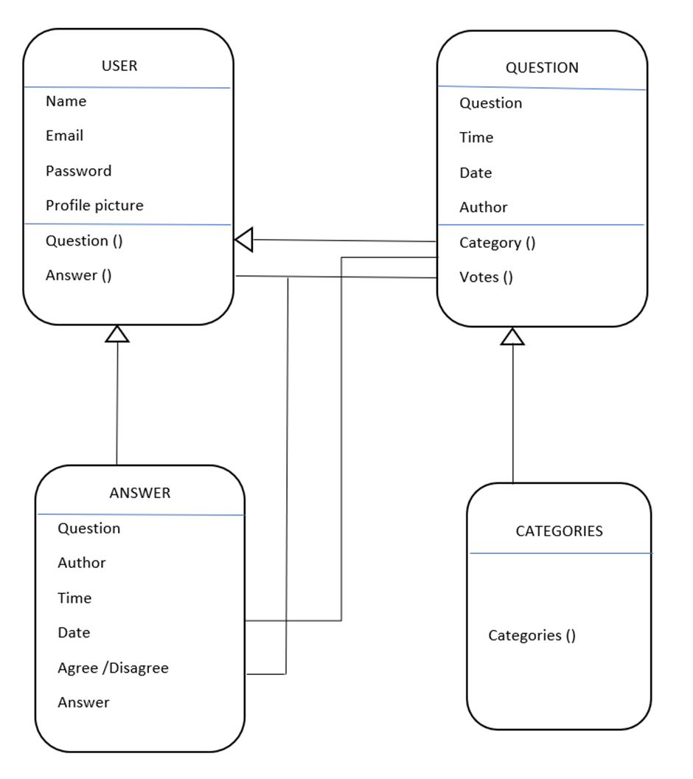

**Figure 4.1. UML diagram**

**4.2.1 Description of UML diagram:**

The UML diagram referring figure 4.1. gives a basic idea of terms we have used in our project, starting with the user class, it has attributes, name, email, password, profile picture as user credentials, and he/she also have a choose of asking a question or answering for a question from the feed. From the class question, the input as question is taken from the user, date and time of the post are also registered, user can also have a choice of selecting the category of question for which it belongs. From the class answer, it has a question as an attribute, the user can either answer or also can state his/her opinion on previous replies by others. The function votes is given to rate the question so that it helps in filtering out the questions based on a category and the votes count.

**4.3 Database Tables**

For database management in this project we’ve used *sqlite3* which is inbuilt in *Django.* We’ve created four tables i.e they are ‘***User***’, ‘***Question***’, ‘***Answers***’, and ‘***Category***’. Once after activating the virtual environment and installing *Django, Models.py* file can be created and tables can be made using standard *Python* language and following *Django* provided guidelines*.* Tables can be made by executing the following two commands.

*python3.9 manage.py makemigrations*

*python3.9 manage.py migrate*

*(*Assuming python3.9 and Django was installed in virtual env*)*

Respective execution codes of the tables ‘***User***’, ‘***Question***’, ‘***Answers***’, and ‘***Category***’ can be seen in Figure **4.2, 4.3, 4.4** and **4.5.**

**User Table**

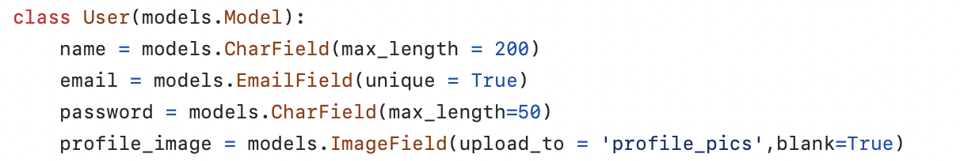

**Figure 4.2. Code for preparation *User* table**

**Question Table**

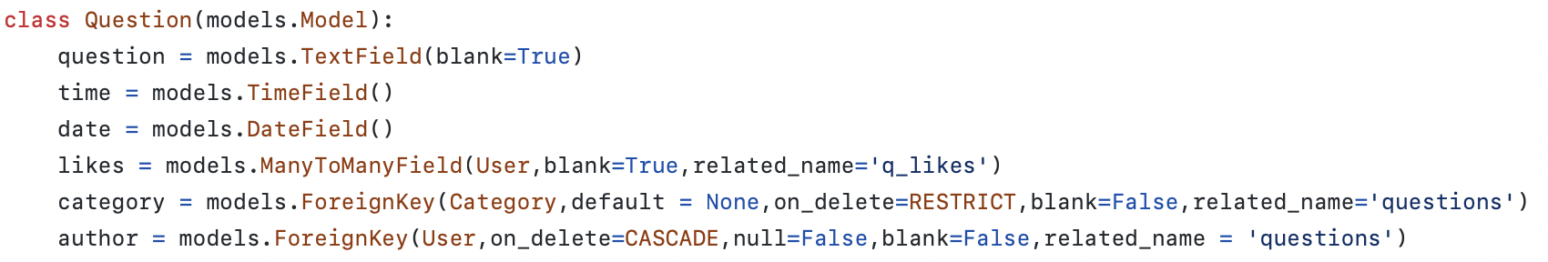

**Figure 4.3. Code for preparation *Question* table**

**Answer Table**

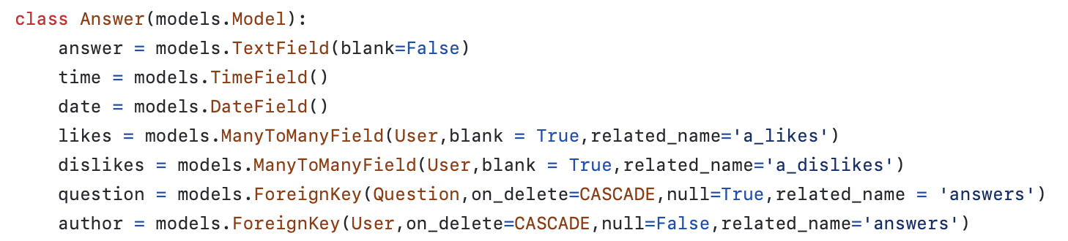

**Figure 4.4. Code for preparation *Answer* table**

**Category Table**



**Figure 4.5. Code for preparation *Category* table**

**4.4 Webpages and their Design**

**4.4.1 Login Page**

The first loaded page of our web application named ‘**READIT**’ is the sign in/sign up page. This page has two forms one for sign in and the other for sign up, two separate forms are used for both of them to pop up individually which was done using javascript. ‘***Sign-up***’ button is used to pop up sign up form and ‘***Sign-in***’ button which pops up sign in form.

In sign up form the user has to enter his name, email (shouldn't be already registered in the web application), along with his password and another field to confirm his password which should be the same as the password entered in the above field. After entering the mentioned fields and by achieving the required criteria user will be redirected to the profile uploading page where user should be able to upload his profile page and tap button ‘***Next****’* to upload and proceed further else user has another option to skip this option by tapping the button ‘***Skip****’* which will make user go further but this time a default profile picture will be displayed.

In sign in form the user has to be registered and must be gone through the sign up form. Here the user should be able to login using his registered email id and password. If password matches to the account matching to the registered emails id’s password user will be redirected to the next page else an error message will appear. From here upon entering correct user credentials user will be redirected to the profile page if still he hasn’t uploaded a profile image else he will be redirected directly to the following page.

**4.4.2 Navigation Bar**

**4.4.2.1 Readit button and Search Bar**

Navigation bar isn’t a separate web page but a constant part for every web page starting from once the user logs in and till he logs out, this made us make navigation bar as a separate sub topic to explain how it's designed and made. On the most right side of the bar there is a ‘***READIT’*** button which takes the user to home irrespective of the page he is in.

Next to that there is a search bar which lets users search for another user account by typing and tapping the search icon, this takes the user to the search page by displaying appropriate search results by using *Django* filter search and using tag ‘*__contains’* which helps filter users.

**4.4.2.2 Directing Bar**

Now coming to the next section i.e Directing bar this has 4 buttons named ‘***MyProfile***’, ‘***AboutUs***’, ‘***ContantUs***’ buttons which takes the user to that appropriate page by clicking the respective button irrespective of the page he’s in.

And there's a final button to the leftmost of the bar named ‘***LOGOUT’*** which makes users log out and takes them back to the home page.

**4.4.3 Home Page**

Once the user logs in and completes appropriate tasks he first starts at the Home page. This page has a navigation bar at the top followed by it’s contents. Bottom of the navigation bar there will be a category and filter selector which will be used to select category of the topic and filter questions by oldest and newest questions

And coming to the main portion there will be questions displayed where there will be votes, replies and proper information displayed, along with that we would also display the active categories on the right side which shows the trending topics which has another box just below it which shows stats such as number of users and number of questions asked.

**4.4.4 Profile Page**

**4.4.4.1 My Profile Page**

My Profile page is the next complex page we have which will be used to display the contents of a user.My profile page shows the content of that particular user. This page also has a navigation bar to navigate around. It will display the profile image alongside showing the name and email of that particular user account. There are also two other options to upload or update his/her profile image, name or password. A new image can be uploaded and hit the ‘***Upload***’ button which updates the image. To change name and password , a new name can be added or for the password a new password can be typed two times for confirmation.

There’s a separate section below the above contents to display questions that the user has asked and questions which are answered by that account along with their respective data.

**4.4.4.2 User Profile Page**

User Profile Page is so similar to My Profile page except unlike my profile page, here no options to edit will be displayed.In simple words this page will be used to display other users data.

**4.4.5 About Us**

The About Us page is used to show information about us. This page also has a navigation bar to navigate around. This page starts with a little introduction text and logo of our page bottom so that we had information about all our six teammates with image, name, reg no and email for further communication alongside our linkedin profile links embedded in them. Unlike other pages this page has no functionality and has simpler html and css code used.

**4.4.6 Contact Us**

The contact Us page is used to contact the administration side of the website. Just like many pages mentioned above, this page too has a navigation bar in it. In this page there will be three input columns with user name and user email and message or feedback which needs to be sent. The input columns user name and email will be pre populated with the information of the user and cannot be changed. As of now the received feedback will not be saved due to storage constraints but can be done with simple steps.

**CHAPTER 5**

RESULTS AND DISCUSSIONS

**5.1 Results**

**5.1.1. Login page**

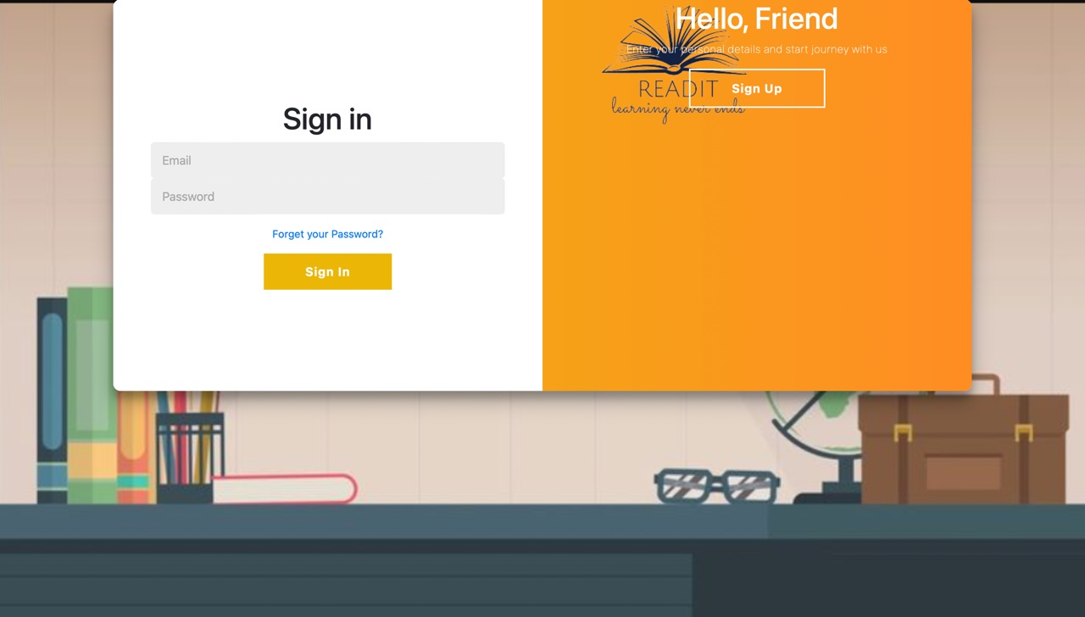

**Figure 5.1. Sign in**

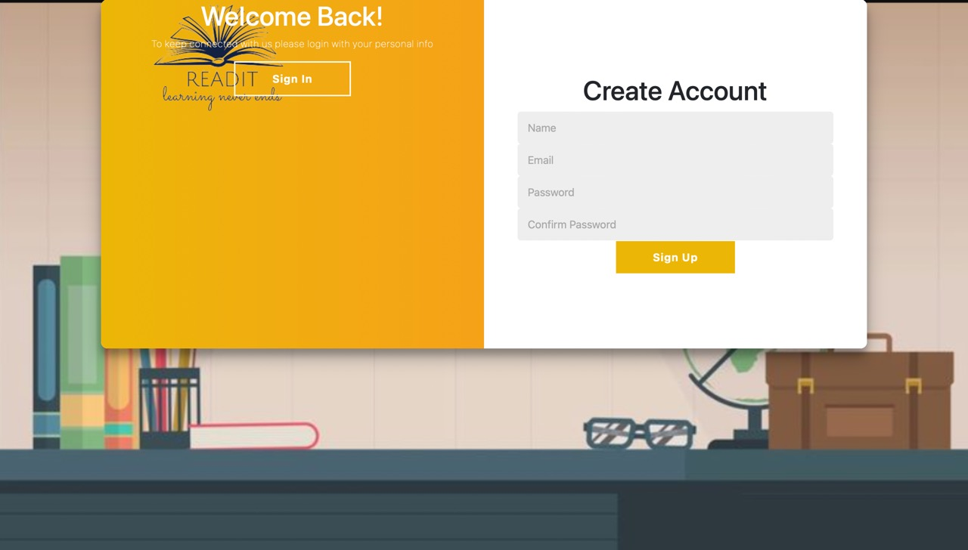

**Figure 5.2. Sign up**

**5.1.2. Home page**

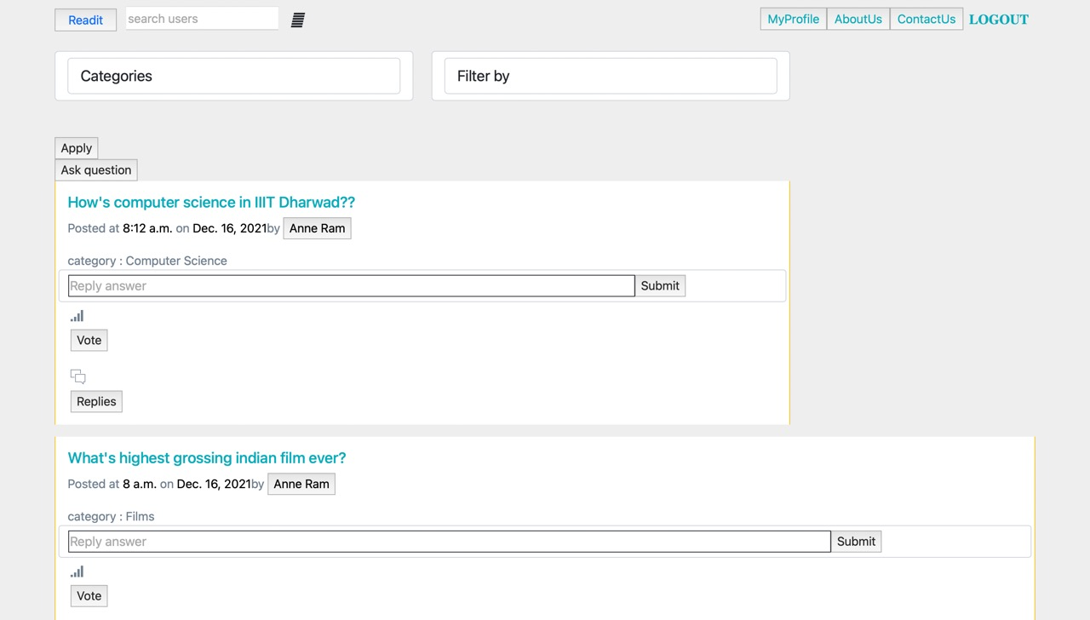

**Figure 5.3. Home page(home feed)**

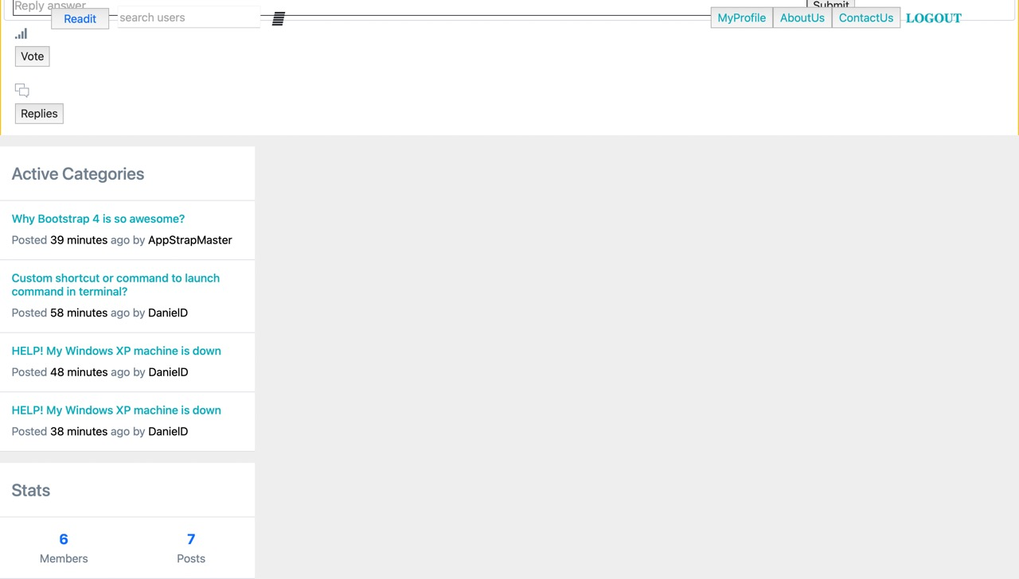

**Figure 5.4. Active categories**

**5.1.3. My Profile**

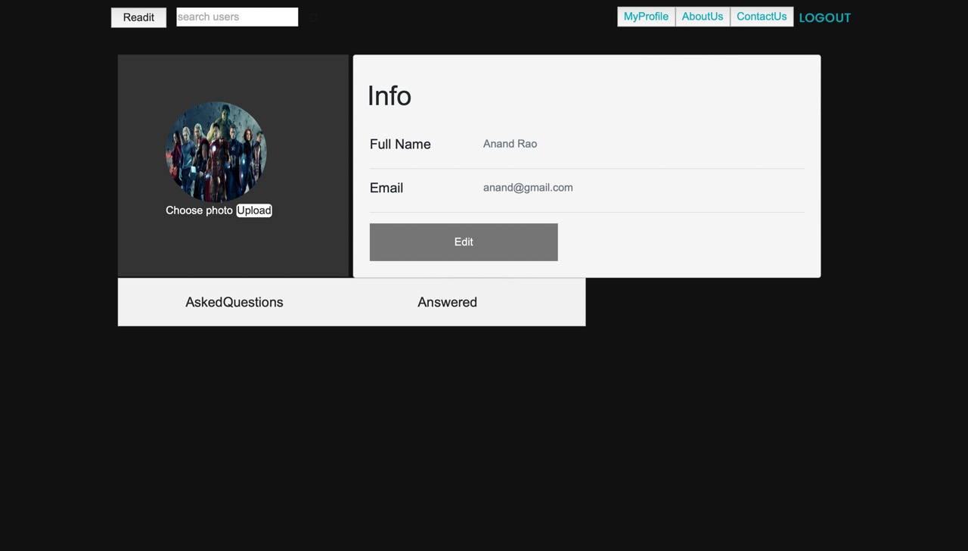

**Figure 5.5. My profile**

**5.1.4. About Us**



**Figure 5.6. About us**

**5.1.5. Contact Us**

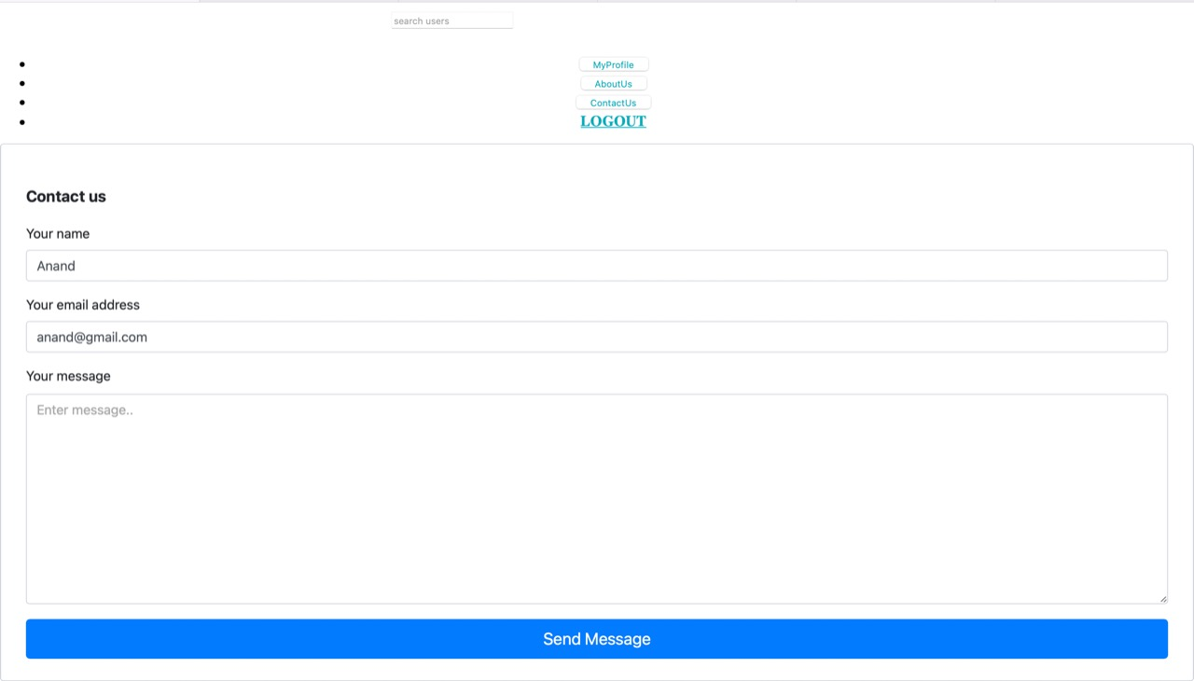

**Figure 5.7. Contact us**

**5.2 Discussions**

As a result, we built a website that works with any browser. Updates will be possible in this forum in the future. Users will become more connected by using this forum. The purpose of this forum is to provide a platform for communication between people from different areas. This project is to create online forms that facilitate group discussion. This is a web-based tool. Using the site, any user can post a topic of their doubts and reply to that of another user. The user can invite other users to a discussion and post a question. It is helpful for small offices, schools, departments, or for that matter any group that seeks effective organization. The ability to share the resource and post articles that can be viewed by registered users.

**CHAPTER 6**

**SUMMARY**

Now-a-days most of the students are spending a huge amount of time on the internet for learning and clearing the concepts. So in that case there is a huge need for the students to have a path in clearing their doubts. Our project " INFORMATIVE WEBSITE (READIT)" meet with these requirements, it helps the users in clearing the doubts, the users have a choice of asking or answering the question. This project meets all these user-friendly requirements.

We have used HTML, CSS, JavaScript, django, bootstrap for the frontend and backend development of the website. Firstly we have a signin / signup page for the user to login, we have created a profile page to track out the status of the user and their recent activities.We have also created a home page with home feed which pops out the latest questions from the users of the website, also has a section for active categories helps in finding trending topics. The user has the opportunity of filling the answers, also voting the questions or stating the agree or disagree for the replies and commenting. The users also can search for the questions based on categories (the question belongs in general) and number of votes for the question, in this way while posting the question the user has to select the category and post it. Thus our website has its own features which helps the user in exploring their knowledge.

**CHAPTER 7**

**REFERENCES**

1. Udemy course of Django created by Maximilian Schwarzmüller - <https://www.udemy.com/course/python-django-the-practical-guide/>
2. Django official documentation - <https://docs.djangoproject.com/en/4.0/>
3. <https://studentprojectguide.com/java-projects/online-discussion-forum/>
4. Dhanielly P. R. de Lima ET. AI. , (2014) <https://anaheim.edu/about-anaheim-university/background-2/203-about/resources/75-online-discussion-forum.html>
5. <https://www.hindawi.com/journals/edri/2014/589860/> (2014)
6. <https://www.academia.edu/40456435/DISCUSSION_FORUM_FOR_STUDENTS_AND_FACULTY_> (2019)
7. <https://www.researchgate.net/publication/254735438_Analyzing_Internet_Forums_A_Practical_Guide> (2012)
8. <https://pdfcookie.com/documents/online-discussion-forum-project-report2-9lgrnwrngr2o>
9. <https://www.w3schools.com/html/default.asp>
10. <https://www.w3schools.com/css/default.asp>
11. <https://getbootstrap.com/docs/5.1/getting-started/introduction/>